CS5381 Evolutionary Algorithm Report

1. Parameter Configuration
Student Name: Rezuan Chowdhury Rifat
Tested Use Case: CartPole Control Optimization
Population Size: 10
Generations: 10
Selection Strategy: Top-k (k=2)
Mutation Strategies:
- No Evolution
- Random Mutation
- LLM-Guided Mutation
LLM Integration: OpenAI-based mutation

2. Performance Data Summary
Generation Count: 10 per method.
Runtime:
- No Evolution: Fastest (minimal computation)
- Random Mutation: ~0.001–0.002 seconds per generation
- LLM-Guided Mutation: ~16 seconds per generation (API overhead)
Steps per Generation:
- No Evolution: Constant (~400 steps)
- Random Mutation: Fluctuates (~427–436 steps)
- LLM-Guided Mutation: Converges to ~440 steps

3. Comparative Analysis
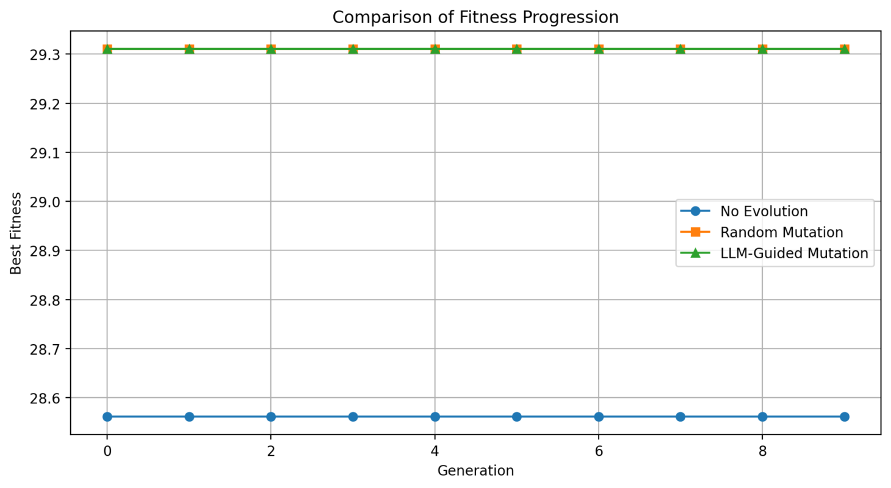
Fitness Progression:
- No Evolution: Constant (~28.56)
- Random Mutation: Slight improvement (~29.03–29.18), unstable
- LLM-Guided Mutation: Rapid convergence (~28.90 → ~29.31)
Variance:
- No Evolution: 0 (no diversity)
- Random Mutation: Moderate, fluctuating
- LLM-Guided Mutation: High initially, then stabilizes to 0

4. Observations
- No Evolution: No learning
- Random Mutation: Some exploration, unstable
- LLM-Guided Mutation: Best performance and fastest convergence

5. Conclusion
LLM-guided mutation significantly outperforms traditional approaches in fitness and convergence. However, it has higher computational cost due to API usage.
